- DEADLINES:
- Deadline for submitting the application form – by August 31, 2021
- Deadline for payment of the fee – by September 15, 2021
- Deadline for submitting the paper – by September 30, 2021
- Conference date –25-26 November 2021

- CONFERENCE FEE
PLN 1,600 – participation in the conference with publication of the paper in the Scientific Papers of the Silesian University of Technology, with accommodation
(the fee covers: accommodation during the conference, participation in the debates, conference materials, meals, participation in accompanying events, including a thermal pool)
PLN 1,450 – participation in the conference with publication of the paper, without accommodation
(the fee covers: meals, participation in the debates, conference materials, participation in accompanying events)
PLN 1,150 – participation in the conference without publication of the paper, with accommodation (the fee covers: accommodation during the conference, participation in the debates, conference materials, meals, participation in accompanying events, including
a thermal pool)
PLN 1,050 – publication of the paper without participation in the conference
(the fee covers: publication in the Scientific Papers of the Silesian University of Technology. Series: Organization and Management)
PLN 1,050 – on-line participation in the conference with publication of the paper
Transfer details:
Fundacja Innowacyjnego Rozwoju i Wiedzy
ul. Piłsudskiego 4/35, 85-793 Bydgoszcz
NIP: 554 292 44 76
Volkswagen Bank Polska S.A., account number: 43 2130 0004 2001 0665 1988 0001
With a description: Name and surname, Competitiveness and Development -WZ
EUR 300 – option to publish the paper in the International Review journal
For more information visit: http://www.international-review.com/en/home/
or contact us at the following email address: aleksandra.tosovic.stevanovic@gmail.com
Organisers
Department of Economy and Marketing  Department of Management  University of Science and Technology in Bydgoszcz | Department of Management and Logistics  Faculty of Organisation and Management  Silesian University of Technology
Foundation for Innovative Development and Knowledge in Bydgoszcz

Organizatorzy

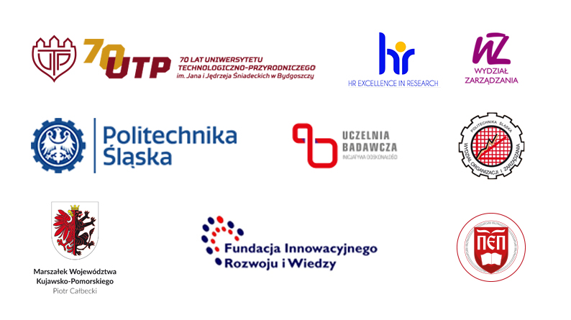8th National Scientific Conference
in the series
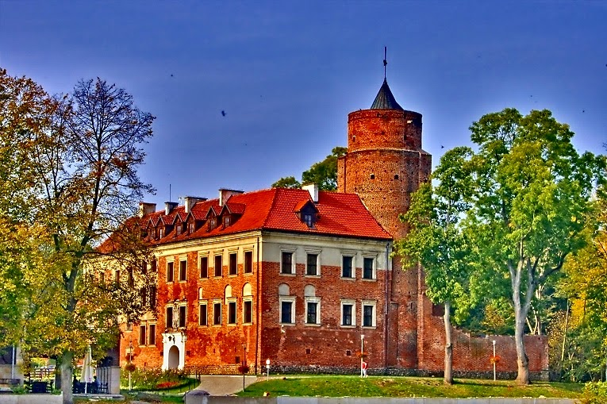

Konkurencyjność i rozwój regionów
w warunkach integracji europejskiej
i globalizacji.
Stan - Trendy – Strategie

8th National Scientific Conference in the series: "Competitiveness and development of regions
in the context of European integration and globalization.
State - Trends - Strategies"

25-26 November 2021 r.
UNIEJÓW THERMAL RESORT

25-26 listopada 2021 r.
UNIEJÓW UZDROWISKO TERMALNE

- GOALS OF THE CONFERENCE

The aim of the conference is to exchange views and experiences as well as to present the latest scientific research results concerning competitiveness and development of regions in the context of European integration and globalization. An important goal of the conference is also the integration of representatives of science, business, and local government.

- SUBJECT AREAS OF THE CONFERENCE

- The influence of European integration and globalization as well as internal conditions on the growth of competitiveness and development of regions;
- Education management;
- Partnership in creating value for stakeholders in the region;
- Problems of contemporary logistics in highly industrialized regions;
- The impact of marketing management on regional competitiveness and development;
- Managing organizations in the era of building Society 5.0;
- Media and social communication as part of the region's information system.
For a more detailed range of subject areas please visit: http://wz.utp.edu.pl
under Learning & Collaboration tab.

- PUBLICATION
Scientific Papers of Silesian University of Technology. Organization and Management Series (ISSN 1641-3466) - 20 points acc. to the Ministry of Science and Higher Education, English,
Databases: Baztech, Bazecon, IndexCopernicus, DOAJ Directory of Open Access, Journals, J-Gate, EBSCO, GoogleScholar.
Instructions for Authors of Papers can be found at the following website: http://organizacjaizarzadzanie.blogspot.com/
The publication should be prepared both in English and Polish.
Articles in electronic version should be sent to the conference organizer at
the following email address: mkasprowicz@utp.edu.pl

Additional possibility of publication in the International Review journal (ISSN 2217-9739) - 20 points according to the Ministry of Science and Higher Education, English, subject matter: economics and finance; management and quality sciences.
All information can be found at the following website: http://www.international-review.com/en/home/

- PLACE OF THE CONFERENCE:

- Zamek Arcybiskupów Gnieźnieńskich - Uniejów Thermal Resort
ul. Zamkowa 2, 99-210 Uniejów
Website: http://www.termyuniejow.pl/

- CONFERENCE PROGRAM BOARD:
dr hab. Krzysztof Andruszkiewicz, university prof. - University of Science and Technology in Bydgoszcz – Head of the Programme Board
dr hab. inż. Krzysztof Wodarski, prof. PŚ - Silesian University of Technology – 1st assistant of the Head of the Programme Board
dr Maciej Schulz - University of Science and Technology in Bydgoszcz – 2nd assistant of the Head of the Programme Board
dr hab. Wiesław Ciechomski, prof. UEP - Poznań University of Economics
dr hab. Izabela Jonek-Kowalska, prof. PŚ - Silesian University of Technology
prof. dr hab. Stanisław Kaczmarczyk - University of Science and Technology in Bydgoszcz
dr hab. Wiesława Kuźniar, prof. UR - Rzeszów University
dr hab. Aleksandra Kuzior, prof. PŚ - Silesian University of Technology
dr inż. Małgorzata Michalcewicz-Kaniowska - University of Science and Technology in Bydgoszcz
dr hab. inż. dr h.c Bartosz Mickiewicz, prof. ZUT - West Pomeranian University of Technology in Szczecin
dr hab. inż. Paweł Mickiewicz, prof. ZUT - West Pomeranian University of Technology in Szczecin
prof. dr hab. inż. Wiesław Musiał - University of Agriculture in Krakow
dr hab. Lech Nieżurawski, prof. WSB - School of Banking in Toruń
dr hab. inż. Monika Odlanicka-Poczobutt, prof. PŚ - Silesian University of Technology
dr hab. Robert Romanowski, prof. UEP - Poznan University of Economics
dr hab. Sebastian Stępień, prof. UEP - Poznan University of Economics
dr hab. inż. Radosław Wolniak, prof. PŚ - Silesian University of Technology
dr inż. Małgorzata Zajdel - University of Science and Technology in Bydgoszcz
prof. nadzw. dr. Ing. Marie Gabryšová - Hornoslezská vysoká škola obchodni Zahraniční fakulta
v Ostravě (Upper Silesian College of Commerce)
prof. Kirill Rozhkov - National Research University Higher School of Economics in Russia
dr Andrei Tsimayeu - Belarusian State Agricultural Academy in Gorki
prof. Mustafa Kurt - Yalova University in Yalova, Turkey
Sef lucr. dr. Cosmina-Simona TOADER - Universitatea de Stiinte Agricole si Medicina Veterinara
a Banatului ''Regele Mihai I al Romaniei'' din Timisoara in Romania
doc. dr. sc. Jurica Bosna – University of Zadar in Croatia
Aleksandra Tošović-Stevanović, PhD, Associate Professor, Faculty of Business Economics and Entrepreneurship, Belgrade, Serbia
Vladimir Ristanović, PhD, Research Fellow, Institute of European Studies, and Faculty of Business Economics and Entrepreneurship, Belgrade, Serbia
Slađana Vujičić, PhD, Associate Professor, Faculty of Business Economics and Entrepreneurship, Belgrade, Serbia
ORGANISING COMMITTEE

dr inż. Małgorzata Michalcewicz-Kaniowska - Chair of the Organising Committee,
tel. (+48) 52 340 81 76, email: malgosia@utp.edu.pl
dr hab. Monika Odlanicka-Poczobutt, prof. PŚ – 1st assistant of the Chair of the Organising Committee,
e-mail: monika.odlanicka-poczobutt@polsl.pl
mgr inż. Magdalena Kasprowicz - secretary, tel. (+48) 52 340 84 88, email: mkasprowicz@utp.edu.pl
mgr Anna Horodecka – 2nd secretary, email: anna.horodecka@polsl.pl
dr inż. Anna Murawska – member of the Organising Committee, email: anna.murawska@utp.edu.pl
dr inż. Małgorzata Zajdel - member of the Organising Committee, email: m.zajdel@utp.edu.pl

