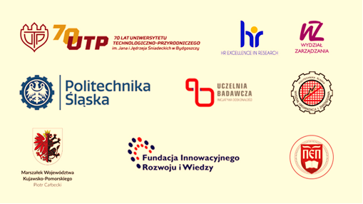
University of Science and Technology
in Bydgoszcz

Silesian University of Technology

Foundation for Innovative Development
and Knowledge in Bydgoszcz

25-26 November 2021
UNIEJÓW THERMAL RESORT

8th National Scientific Conference
Competitiveness and development of regions in the context of European integration and globalization.
State - Trends - Strategies
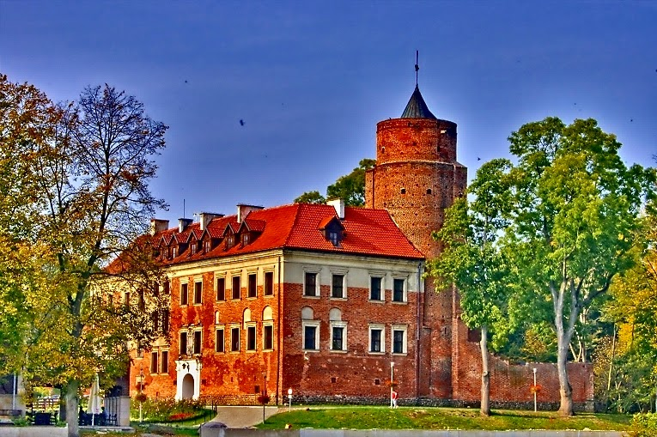
Conference subject areas

The influence of European integration and globalization as well as internal conditions
on the growth of competitiveness and
development of regions

Education management

Partnership in creating value
for stakeholders in the region

Problems of contemporary logistics
in highly industrialized regions

The impact of marketing management
on competitiveness and development of the region

Managing organizations in the era of
building Society 5.0

Media and social communication
as an element of the region's information system
Find out more and register at:
https://wz.utp.edu.pl/zaproszenie-do-udzialu-w-viii-ogolnopolskiej-konferencji-naukowej-pt-konkurencyjnosc-i-rozwoj-regionow-w-warunkach-integracji-europejskiej-i-globalizacji-stan-trendy-st/
Important dates Contact e-mail: mkasprowicz@utp.edu.pl

Submission of the application form by August 31, 2021.
Payment of the fee by September 15, 2021.
Submission of the paper by September 30, 2021.
On-line conference in case of any restrictions
applicable as the result of the COVID-19 pandemic

